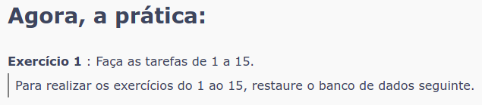
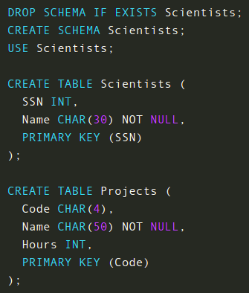

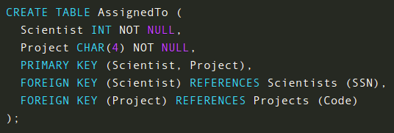

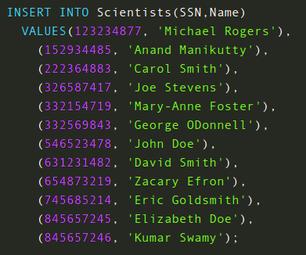

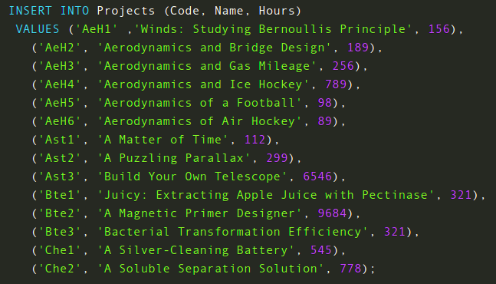

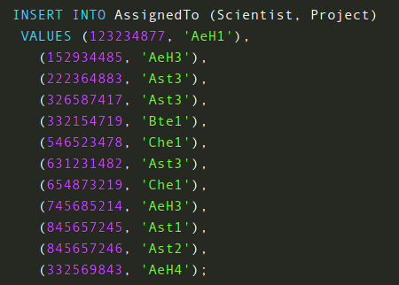

DROP SCHEMA IF EXISTS Scientists;
CREATE SCHEMA Scientists;
USE Scientists;

CREATE TABLE Scientists (
SSN INT,
Name CHAR(30) NOT NULL,
PRIMARY KEY (SSN)
);

CREATE TABLE Projects (
Code CHAR(4),
Name CHAR(50) NOT NULL,
Hours INT,
PRIMARY KEY (Code)
);

CREATE TABLE AssignedTo (
Scientist INT NOT NULL,
Project CHAR(4) NOT NULL,
PRIMARY KEY (Scientist, Project),
FOREIGN KEY (Scientist) REFERENCES Scientists (SSN),
FOREIGN KEY (Project) REFERENCES Projects (Code)
);

INSERT INTO Scientists(SSN,Name)
VALUES(123234877, 'Michael Rogers'),
(152934485, 'Anand Manikutty'),
(222364883, 'Carol Smith'),
(326587417, 'Joe Stevens'),
(332154719, 'Mary-Anne Foster'),
(332569843, 'George ODonnell'),
(546523478, 'John Doe'),
(631231482, 'David Smith'),
(654873219, 'Zacary Efron'),
(745685214, 'Eric Goldsmith'),
(845657245, 'Elizabeth Doe'),
(845657246, 'Kumar Swamy');

INSERT INTO Projects (Code, Name, Hours)
VALUES ('AeH1' ,'Winds: Studying Bernoullis Principle', 156),
('AeH2', 'Aerodynamics and Bridge Design', 189),
('AeH3', 'Aerodynamics and Gas Mileage', 256),
('AeH4', 'Aerodynamics and Ice Hockey', 789),
('AeH5', 'Aerodynamics of a Football', 98),
('AeH6', 'Aerodynamics of Air Hockey', 89),
('Ast1', 'A Matter of Time', 112),
('Ast2', 'A Puzzling Parallax', 299),
('Ast3', 'Build Your Own Telescope', 6546),
('Bte1', 'Juicy: Extracting Apple Juice with Pectinase', 321),
('Bte2', 'A Magnetic Primer Designer', 9684),
('Bte3', 'Bacterial Transformation Efficiency', 321),
('Che1', 'A Silver-Cleaning Battery', 545),
('Che2', 'A Soluble Separation Solution', 778);

INSERT INTO AssignedTo (Scientist, Project)
VALUES (123234877, 'AeH1'),
(152934485, 'AeH3'),
(222364883, 'Ast3'),
(326587417, 'Ast3'),
(332154719, 'Bte1'),
(546523478, 'Che1'),
(631231482, 'Ast3'),
(654873219, 'Che1'),
(745685214, 'AeH3'),
(845657245, 'Ast1'),
(845657246, 'Ast2'),
(332569843, 'AeH4');

